Project Design Phase
Problem – Solution Fit Template
Date | 12 July 2026
Team ID | [Enter Team ID]
Project Name | Smart Lender – Loan Approval Prediction System
Maximum Marks | 2 Marks

Problem – Solution Fit
The canvas below confirms that Smart Lender's ML-based scoring solution actually fits the credit officer's real behaviour, constraints and triggers, rather than solving a problem no one has.
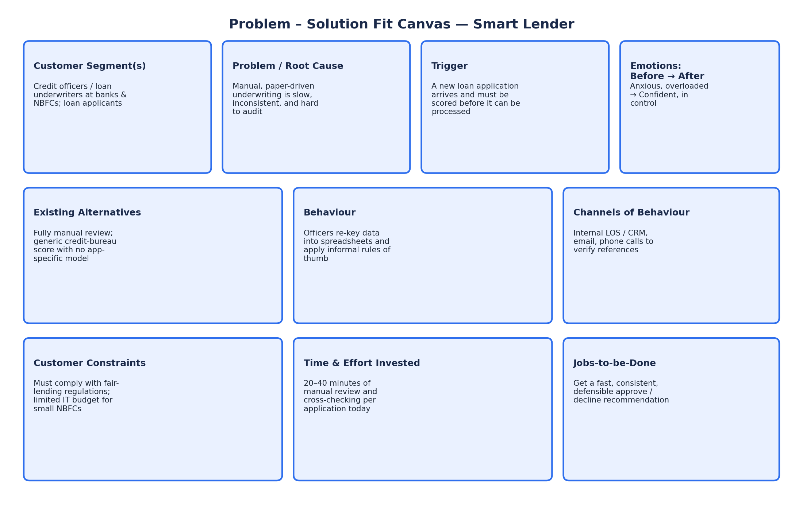

Fit summary
- Trigger and behaviour line up: every incoming application already forces the officer into the same manual checklist, so an automated score slots directly into an existing workflow step rather than creating a new one.
- The emotional shift (anxious/overloaded → confident/in-control) is achievable because the solution keeps the officer in the loop — it recommends a decision and a confidence level, it does not remove human sign-off.
- Regulatory and budget constraints are respected: the model runs on lightweight, open-source libraries (scikit-learn/XGBoost) that a small NBFC can host cheaply, and the comparison report gives an auditable basis for the recommendation.

